**Lab Practical #06:**

Study the concept of VLAN using packet tracer.

**Practical Assignment #06:**

1. **Implement the different network structures in VLAN and VLAN trunking. Also check connectivity between them using ping command or PDU utility.**

**Instructions:**

1. Different VLANs configuration setup screenshot. (VLAN example given by lab faculty)
2. Write steps to create VLANs in packet tracer.
3. Mention IP address of each pc as label.
4. Ping command or PDU screenshot between two VLANs.
5. **VLAN EXAMPLE 1**

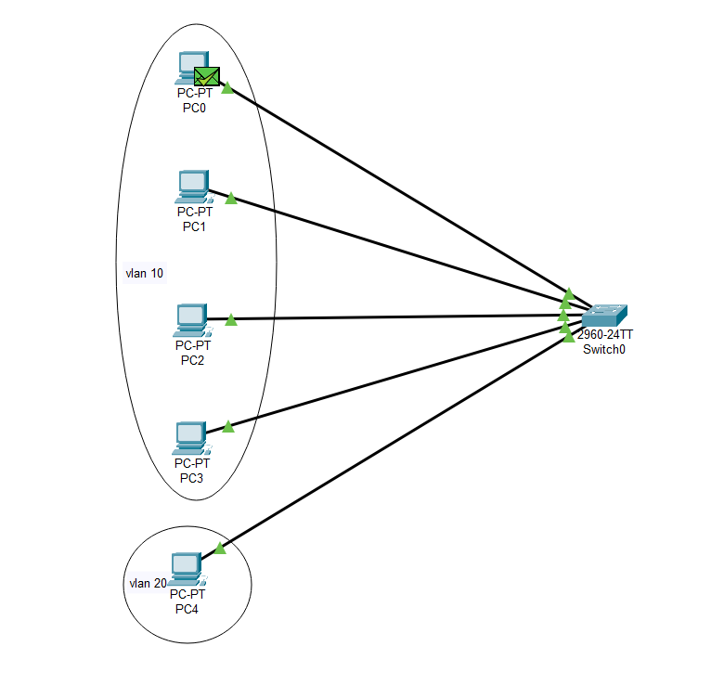

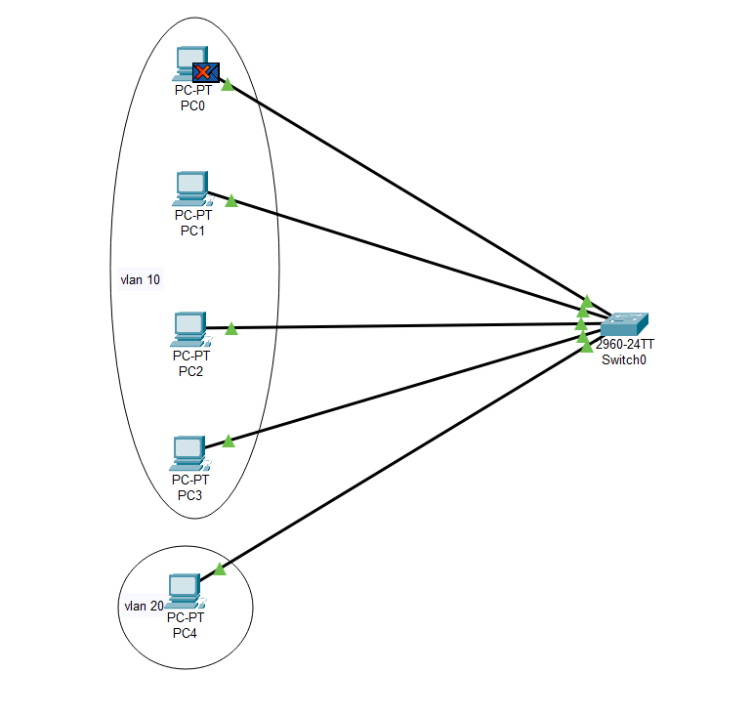

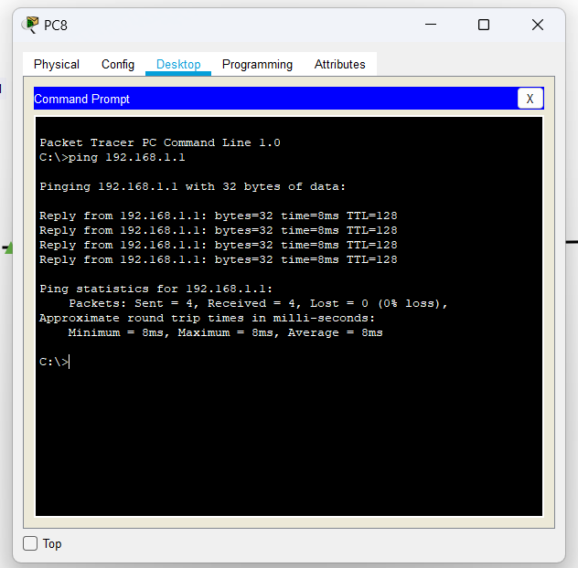

1. **VLAN EXAMPLE 2**

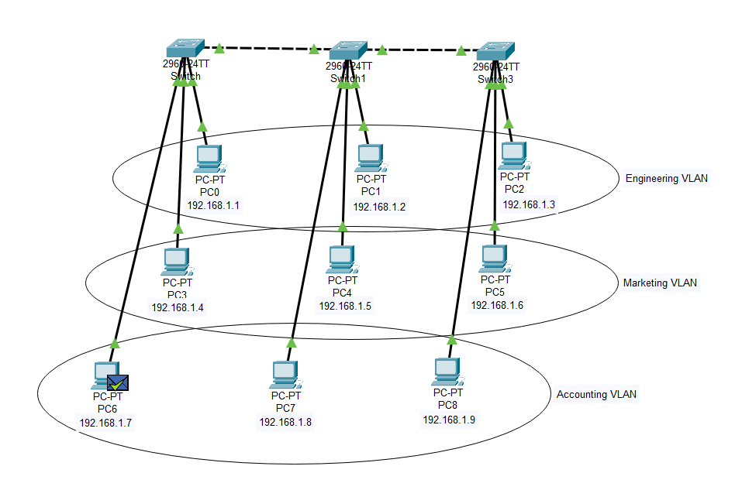

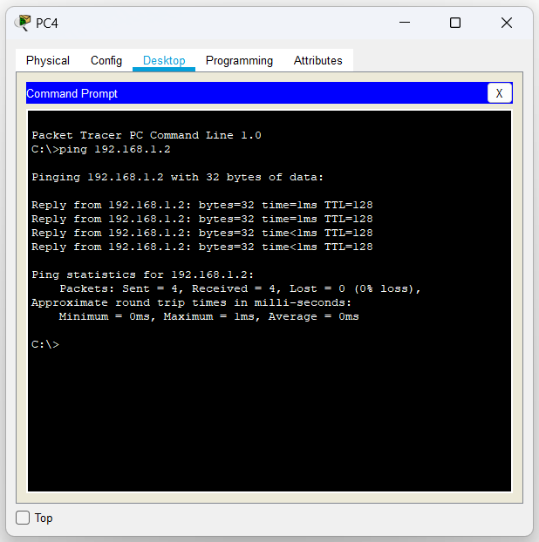

1. **VLAN EXAMPLE 3**

